**Hymn**

And did those feet in ancient time  
walk upon England's mountains green?   
And was the holy Lamb of God  
on England's pleasant pastures seen?  
And did the countenance divine  
shine forth upon our clouded hills?  
And was Jerusalem buildéd here  
among those dark satanic mills?  
  
Bring me by bow of burning gold!  
Bring me my arrows of desire!  
Bring me my spear! O clouds, unfold!  
Bring me my chariot of fire!  
I will not cease from mental fight,  
nor shall my sword sleep in my hand,  
till we have built Jerusalem  
in England's green and pleasant land.

**The Committal and Blessing**

**Leaving the Crematorium**

As we leave the crematorium we will play “Dance with my Father” by Luther Vandross.

**In Loving Memory of**

**Alan Pucill**

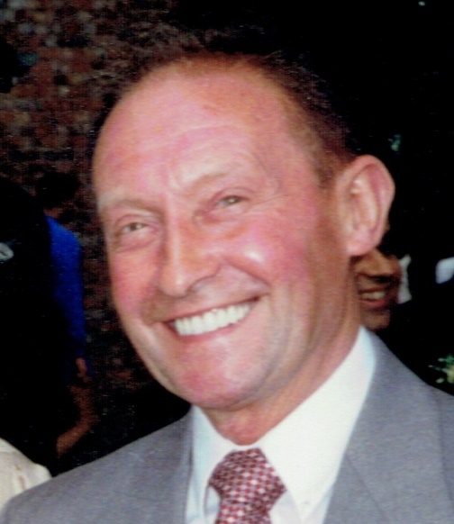

**4th August 1933 – 6th August 2015**

**Warrington Crematorium**

**11:00am**

**28th August 2015**

Music: “Smile” by Nat King Cole

**Introduction and Opening Prayers**

Merciful Father, hear our prayers and comfort us; renew our trust in your Son, whom you raised from the dead; strengthen our faith that all who have died in the love of Christ will share in his resurrection; who lives and reigns with you, in the unity of the Holy Spirit, one God, now and for ever. **Amen**.

**Hymn**

**Abide with me;** fast falls the eventide:

the darkness deepens; Lord, with me abide:

when other helpers fail, and comforts flee,

help of the helpless, O abide with me.

Swift to its close ebbs out life's little day;

earth's joys grow dim, its glories pass away;

change and decay in all around I see:

O thou who changest not, abide with me.

I need thy presence every passing hour;

what but thy grace can foil the tempter's power?

Who like thyself my guide and stay can be?

Through cloud and sunshine, Lord, abide with me.

I fear no foe with thee at hand to bless;

ills have no weight, and tears no bitterness,

Where is death's sting? Where, grave, thy victory?

I triumph still, if thou abide with me.

Hold thou thy cross before my closing eyes;

shine through the gloom, and point me to the skies:

heaven's morning breaks, and earth's vain shadows flee;

in life, in death, O Lord, abide with me.

**Bible Reading: John 14. 1-6**

**The Tribute –including Memories of Grandad and words from Grandchildren**

**Poem “Feel no guilt in laughter” read by Victoria**

**Memorable Photographs to “Unforgettable” by Nat King Cole**

**The Prayers**

*After “Lord, in your mercy”, please respond by saying: “****Hear our prayer”***

*After the final section:*

**God of mercy, entrusting into your hands all that you have made and rejoicing in our communion with all your faithful people, we make our prayers through Jesus Christ our Saviour. Amen.**

**The Lord’s Prayer**

**Our Father who art in heaven, Hallowed be thy Name,**

**Thy kingdom come, Thy will be done, on earth as it is in heaven.**

**Give us this day our daily bread; And forgive us our trespasses,**

**As we forgive those who trespass against us;**

**And lead us not into temptation, But deliver us from evil.**

**For thine is the kingdom, the power, and the glory, for ever and ever. Amen.**